ABOUT THE SPEAKER
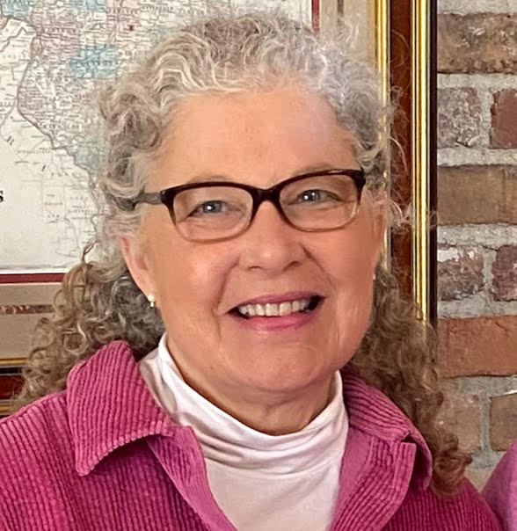

Sharon Brown-Sweeney, PhD, CCC-SLP, earned her B.S. (‘80), M.A. (‘82), and doctorate degree (‘94) from Northwestern University in speech-language pathology. She has worked as a speech-language pathologist in private practice, private school and clinic settings in the Chicago area, Vermont and Dublin, Ireland. Her primary areas of clinical interest have included treating children with speech motor disorders, such as those with cerebral palsy and Down syndrome, as well as working with augmentative and alternative communication (AAC). For the past 25 years, she has been an adjunct academic and clinical faculty member at the undergraduate and graduate levels. She has worked at Rush University, Elmhurst College, and Saint Xavier University in Chicago. She has presented at the state and national conferences and has several publications. Dr. Brown-Sweeney was an active member of the Legislative and Regulatory Affairs Committee of the Illinois Speech-Language-Hearing Association (ISHA) for ten years and served for two years as Vice President of Legislative and Regulatory Affairs on the Executive Board of the organization.

